Alunno 1

Alunno2 Flag02{WweCQnfHohuE4hdusJ67X}

Alunno 3

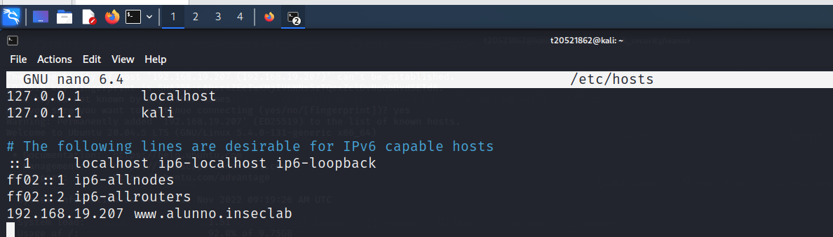

Alunno 4

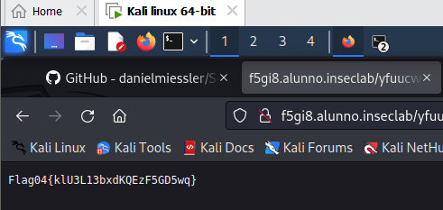

Alunno 5

Aluuno 6

Flag06{OOk6dY82I1iMeR0cShSFD}

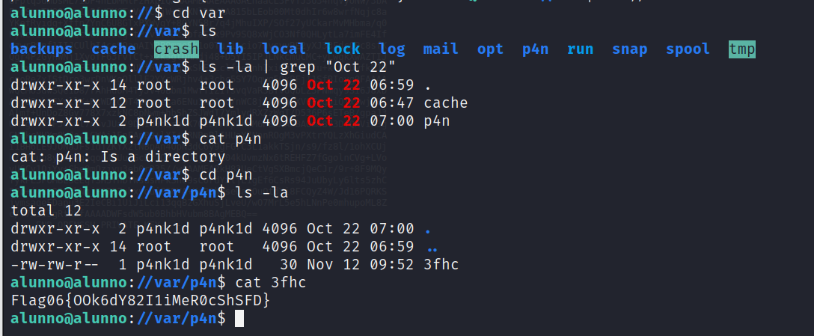

Alunno user

